Exercise 1: Inventory Management System
Understand the Problem:
In a warehouse setting, inventory can run into thousands or even millions of products. Without a proper structure in place, even simple operations like finding a product or updating its quantity become slow and error-prone. That is where data structures come in.
The choice of data structure has a direct impact on how fast we can perform everyday operations. For instance, using a plain array to search by product ID means scanning through every element one by one — fine for 100 items, not so much for 100,000. A HashMap, on the other hand, gives us near-instant lookup regardless of size.
For this exercise, we are looking at:
- How to model the Product data effectively
- Which collection best suits an inventory scenario
- How add, update, and delete operations behave in terms of performance

Setup:
We define a simple Product class to hold each item's details:
public class Product {
private int productId;
private String productName;
private int quantity;
private double price;

public Product(int productId, String productName, int quantity, double price) {
this.productId = productId;
this.productName = productName;
this.quantity = quantity;
this.price = price;
}
// getters and setters...
}

Implementation:
A HashMap<Integer, Product> is used here, with productId as the key. This makes lookups, updates, and deletes all O(1) on average.
Map<Integer, Product> inventory = new HashMap<>();

// Add a product
public void addProduct(Product p) {
inventory.put(p.getProductId(), p);
}

// Update quantity
public void updateProduct(int id, int newQty) {
if (inventory.containsKey(id)) {
inventory.get(id).setQuantity(newQty);
}
}

// Delete a product
public void deleteProduct(int id) {
inventory.remove(id);
}

Analysis:
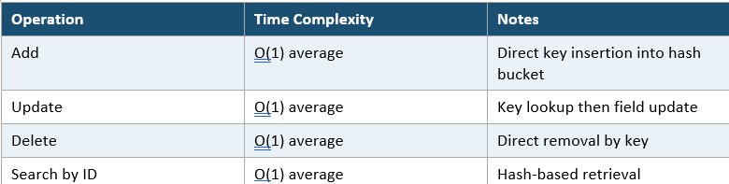

Exercise 2: E-commerce Platform Search Function
Understand Asymptotic Notation:
Big O notation gives us a way to describe how an algorithm's performance scales as the input grows. We are not measuring actual seconds here — we are measuring the rate of growth.
- O(1) — constant time, does not matter how big the input is
- O(log n) — grows very slowly, roughly doubles input = one extra step
- O(n) — linear, one step per element
- O(n log n) — typical of good sorting algorithms
- O(n²) — quadratic, common with nested loops

For search specifically, we care about three scenarios: best case (we get lucky and find it immediately), average case (somewhere in the middle), and worst case (last item or not present at all).

Setup:

public class Product {
private int productId;
private String productName;
private String category;
// constructor + getters
}

Implementation:
public Product linearSearch(Product[] products, int targetId) {
for (Product p : products) {
if (p.getProductId() == targetId) return p;
}
return null;
}

public Product binarySearch(Product[] products, int targetId) {
int low = 0, high = products.length - 1;
while (low <= high) {
int mid = (low + high) / 2;
if (products[mid].getProductId() == targetId) return products[mid];
else if (products[mid].getProductId() < targetId) low = mid + 1;
else high = mid - 1;
}
return null;
}

Analysis:
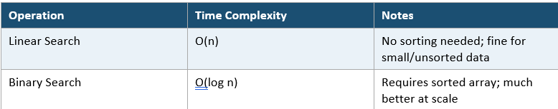

Exercise 3: Sorting Customer Orders
Understand Sorting Algorithms:
Sorting is one of the most studied problems in computer science and for good reason. Getting orders sorted by total price helps prioritise fulfilment, flag high-value customers, or generate reports. Here we look at four algorithms before implementing two of them.
- Bubble Sort — simple but slow; repeatedly swaps adjacent out-of-order elements
- Insertion Sort — builds a sorted section one item at a time; efficient for nearly-sorted data
- Quick Sort — divide and conquer; picks a pivot and partitions around it; very fast in practice
- Merge Sort — divide and conquer; splits, sorts each half, then merges; O(n log n) guaranteed

Setup:
public class Order {
private int orderId;
private String customerName;
private double totalPrice;
// constructor + getters
}

Implementation:
public void bubbleSort(Order[] orders) {
int n = orders.length;
for (int i = 0; i < n - 1; i++) {
for (int j = 0; j < n - i - 1; j++) {
if (orders[j].getTotalPrice() > orders[j+1].getTotalPrice()) {
Order temp = orders[j];
orders[j] = orders[j+1];
orders[j+1] = temp;
}
}
}
}

public void quickSort(Order[] orders, int low, int high) {
if (low < high) {
int pi = partition(orders, low, high);
quickSort(orders, low, pi - 1);
quickSort(orders, pi + 1, high);
}
}

private int partition(Order[] orders, int low, int high) {
double pivot = orders[high].getTotalPrice();
int i = low - 1;
for (int j = low; j < high; j++) {
if (orders[j].getTotalPrice() <= pivot) {
i++;
Order temp = orders[i]; orders[i] = orders[j]; orders[j] = temp;
}
}
Order temp = orders[i+1]; orders[i+1] = orders[high]; orders[high] = temp;
return i + 1;
}

Analysis:
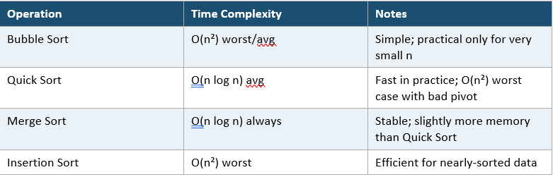

Exercise 4: Employee Management System
Understand Array Representation:
Arrays are contiguous blocks of memory. When you declare an Employee[] of size 10, the JVM allocates 10 consecutive slots. This is what gives arrays their O(1) index access — to get element at index i, the address is simply: base_address + (i * element_size). No traversal needed.
This predictability makes arrays cache-friendly, which matters in performance-critical code. The trade-off is fixed size — you cannot grow or shrink the array once created without creating a new one.

Setup:
public class Employee {
private int employeeId;
private String name;
private String position;
private double salary;
// constructor + getters/setters
}

Implementation:
Employee[] employees = new Employee[100];
int count = 0;

// Add
public void addEmployee(Employee e) {
if (count < employees.length) employees[count++] = e;
}

// Search by ID (linear)
public Employee searchById(int id) {
for (int i = 0; i < count; i++) {
if (employees[i].getEmployeeId() == id) return employees[i];
}
return null;
}

// Traverse all
public void traverse() {
for (int i = 0; i < count; i++) System.out.println(employees[i].getName());
}

// Delete by ID (shift elements left)
public void delete(int id) {
for (int i = 0; i < count; i++) {
if (employees[i].getEmployeeId() == id) {
for (int j = i; j < count - 1; j++) employees[j] = employees[j+1];
employees[--count] = null;
break;
}
}
}

Analysis:
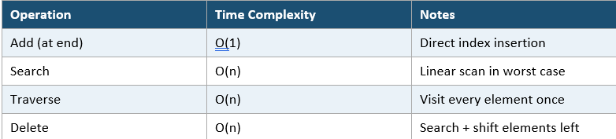

Exercise 5: Task Management System
Understand Linked Lists:
A linked list is a chain of nodes where each node holds data and a reference (pointer) to the next node. Unlike arrays, nodes are not stored contiguously in memory — they are scattered, connected only by these references.
There are two main variants:
- Singly Linked List — each node points only to the next node
- Doubly Linked List — each node has pointers to both next and previous nodes, enabling bidirectional traversal
The key advantage over arrays is that insertions and deletions do not require shifting elements. You simply update a pointer. The downside is that there is no O(1) random access — to reach node at position i, you must walk from the head.

Setup:
public class Task {
int taskId;
String taskName;
String status;
Task next;

public Task(int taskId, String taskName, String status) {
this.taskId = taskId;
this.taskName = taskName;
this.status = status;
this.next = null;
}
}

Implementation:
Task head = null;

// Add at end
public void addTask(Task t) {
if (head == null) { head = t; return; }
Task cur = head;
while (cur.next != null) cur = cur.next;
cur.next = t;
}

// Traverse
public void traverse() {
Task cur = head;
while (cur != null) {
System.out.println(cur.taskId + " - " + cur.taskName);
cur = cur.next;
}
}

// Search
public Task search(int id) {
Task cur = head;
while (cur != null) {
if (cur.taskId == id) return cur;
cur = cur.next;
}
return null;
}

// Delete by ID
public void delete(int id) {
if (head == null) return;
if (head.taskId == id) { head = head.next; return; }
Task cur = head;
while (cur.next != null && cur.next.taskId != id) cur = cur.next;
if (cur.next != null) cur.next = cur.next.next;
}

Analysis:
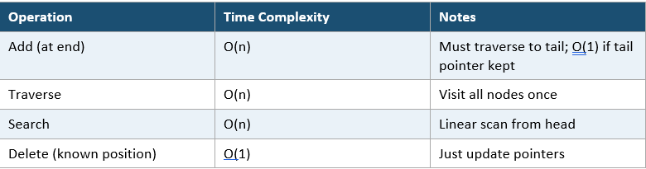

Exercise 6: Library Management System
Understand Search Algorithms:
This exercise revisits linear and binary search but applies them to a library catalog where the key fields are book title and author. The logic is similar to Exercise 2, but now we are searching by string fields rather than an integer ID.
Setup:
public class Book {
private int bookId;
private String title;
private String author;
// constructor + getters
}

Implementation:
public Book linearSearchByTitle(Book[] books, String query) {
for (Book b : books) {
if (b.getTitle().equalsIgnoreCase(query)) return b;
}
return null;
}

public Book binarySearchByTitle(Book[] books, String query) {
int low = 0, high = books.length - 1;
while (low <= high) {
int mid = (low + high) / 2;
int cmp = books[mid].getTitle().compareToIgnoreCase(query);
if (cmp == 0) return books[mid];
else if (cmp < 0) low = mid + 1;
else high = mid - 1;
}
return null;
}

Analysis:
Linear search is appropriate when the dataset is small (a few hundred books), when data is unsorted, or when a quick implementation is needed without preprocessing. Binary search makes sense for large, sorted collections where repeated searches are needed. For a real library system, an indexed database or a Trie for prefix search would be even more practical.
Exercise 7: Financial Forecasting
Understand Recursive Algorithms:
Recursion is when a function calls itself with a smaller version of the original problem. Every recursive solution needs two things: a base case (the stopping condition) and a recursive case (where the function calls itself). Without a base case, you get infinite recursion and a stack overflow.
Financial forecasting is a natural fit for recursion. If we know a value grows at a fixed rate, the value at year n depends directly on the value at year n-1 — which is exactly the kind of structure recursion is good at expressing.
Setup:
public double forecastValue(double principal, double rate, int years) {
if (years == 0) return principal; // base case
return forecastValue(principal * (1 + rate), rate, years - 1);
}
Implementation:
Map<Integer, Double> memo = new HashMap<>();

public double forecastMemo(double principal, double rate, int years) {
if (years == 0) return principal;
if (memo.containsKey(years)) return memo.get(years);
double result = forecastMemo(principal * (1 + rate), rate, years - 1);
memo.put(years, result);
return result;
}

Analysis:
